RJ's Assessment:
Did not adapt it properly for new audiences - used G-d seven times
Already written for someone in the know

Is there more to your work than just labor? Needs to be provocative, attract someone who does not assume their G-d in their life.

App- technically right, but not energetic and exciting enough. If shown to people, would it be compelling enough to make people want this app.

The Simple Health Routine for Body and Soul That You Can Do Every Day
By The Meaningful Life Center

Modern medicine has begun to discover the dramatic effect that a person’s spirit can have on the healing process.
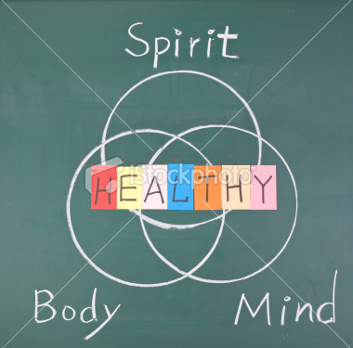

Many people today are health-conscious. We understand that being healthy makes us feel better, makes us more productive, and ultimately lengthens our lives.

Don't worry; you don't have to go on a juice fast.
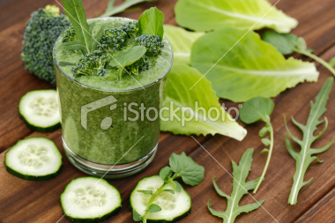

You also don't have to go on a punishing exercise regimen.

Know this: Just as the body is nourished by certain foods, the soul needs spiritual nourishment.
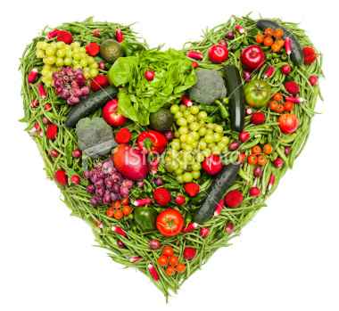
But most significantly, a healthy body allows you to concentrate on your soul, enabling you to fulfill your divine mission in this world and live a meaningful life. The funny thing is, the health of your body is dependent on the health of your soul.

It is your responsibility to nourish them both. When your body or soul cries out, recognize the symptoms for what they are: an urgent request for you to address their needs, be they spiritual or physical.

Here is how to nourish your soul: Learn Torah. If you don't know Hebrew, you can learn in English.

Here's another way to nourish your soul: Do good deeds.
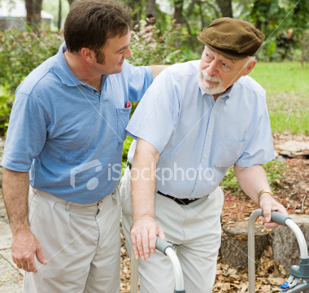

And here's another way to nourish your soul: Prayer, whatever that means to you.

Here is the very good news: We promised you that you don't have to go on a juice fast. You still don't have to go on a juice fast. You do need to eat food that nourishes your body.

You do need to exercise every day, but you don't have to become a bodybuilder.

The big task is: Think positive. The best thing you can do for your spirit and your body is to cultivate an optimistic attitude.

Congratulations! You have just learned how to integrate body and spirit for good health. There's no big bill at a health spa. There's no crazy regimen. Simply eat good food, sleep at night, get some daily exercise, pray in whatever way is meaningful to you, learn spiritual things, and do good deeds. The bottom line: Think good and it will be good!

