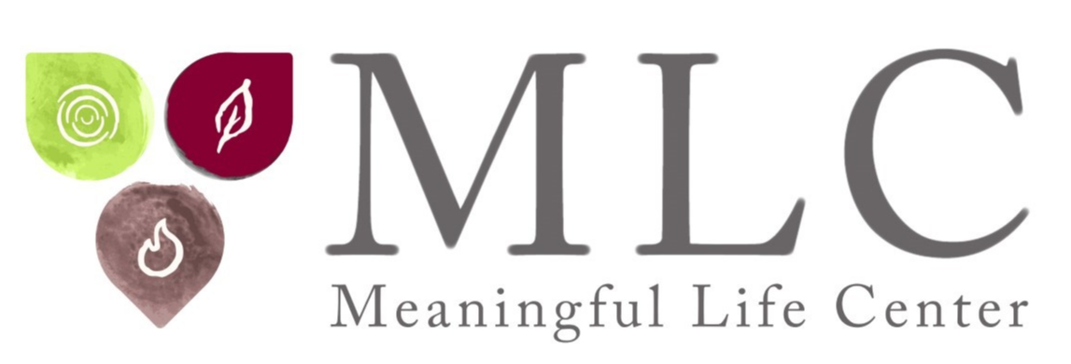

Rabbi Simon Jacobson: Popular Speaking Topics, News and Story Ideas
Rabbi Simon Jacobson can speak on many diverse topics -- yet never gives the same lecture twice; always customizing his talk to the intended audience and event. With his unique approach and mystical lens, Rabbi Jacobson’s messages strive to elevate the spiritual consciousness and guide every person toward living a life of greater meaning, clarity, and purpose.
Below are samples of his most popular lecture topics. Feel free to choose your own title on any topic, and Rabbi Jacobson will be sure to tailor his presentation specifically to your crowd.

How to Disagree Without Hate
In a nation torn by political and racial strife, sage and spiritual leader Rabbi Simon Jacobson offers a refreshing — even revolutionary — new perspective to our current dilemma. He gives direction on how we can stop the mud-slinging grudge match of politics from infecting our health and relationships, along with practical things we can each do to be part of the solution, instead of part of the problem.

The Soul of Sexuality: Can I Find Eternal Love?
We live in a time of crisis for intimacy and relationships. Marriage rates are plummeting and almost half of marriages end in divorce. Discover what 4,000 years of Jewish wisdom says about the art of love and the soul of marriage; igniting the passionate spark of intimacy, resolving conflicts at home, and finding and maintaining fulfilling relationships. Learn how to access the cosmic power of sexuality and how to ride the rollercoaster of married life. For singles and couples alike.

Racism, Protests, & Policing: Black and Blue Lives Matter

Is racism inherent to the human condition, or is there hope for change? How can we cultivate sensitive law officers and maintain law and order? And how can people concerned about excessive police violence respond without becoming part of the problem? Rabbi Jacobson discusses a better way to address discrimination and prejudice based on Biblical principles — how recognizing the intrinsic value of life, a core faith value of Torah, can resolve racial strife.

Decoding the DNA of Your Soul
Rabbi Jacobson shares how to dissect the core emotional energies that make us tick in what he describes as the “4000-Year-Old 7-Step Program” to reclaim the beautiful child trapped in your adult body.

What a Year It Has Been...Has the World Changed Forever

A year like 2020/20201 does not come very often. Disruption on every front. Health. Economic. Political. Leadership. Travel. Leisure. Uncertainty hung over us like a dark cloud. What will the future bring? How can our experiences during the pandemic guide and empower us in forging a new reality? The changes we have lived through seem unprecedented, but the deep well of human history is filled with examples of humanity responding to massive crises, from Biblical plagues to wars against Nazism and totalitarianism. Rabbi Jacobson discusses what the pandemic has taught us about the human condition, its long-term impacts on society and offers powerful lessons and tools to face our challenges.

Addicted and Depressed: How to Break Free
Rabbi Jacobson discusses the role of spirituality in recovery from addiction, depression, and anxiety, along with how to “listen to the cry of your soul,” access a higher power, and live a life of meaning — despite physical, emotional and mental barriers.

How to Heal Our Country
More than 80 million people voted for Joe Biden and more than 74 million voted for Donald Trump. Our country is clearly split. How can we move past divisiveness and partisan politics and pave a path forward? With the catch phrase, “It’s time to heal” being thrown about, Rabbi Jacobson is here to discuss practical ways to build a movement that transcends partisanship and embraces the unibus pluram. Discover ways to not become polluted by the prejudices that are tearing up our country.

Fear & Anxiety: Conquering the Enemies Within
Fear, anxiety, and depression are underlying factors that drive much of human behavior today, and yet they are among the most misunderstood forces in people’s lives. In their most acute form, they paralyze us. How can we conquer these forces? Rabbi Jacobson offers insights based on his studies of 4,000 years of history and faith wisdom, and his four decades of work helping people achieve meaningful lives.

3 Keys to Building a Meaningful Life
Want to live a life with less angst, worry, and stress? Rabbi Jacobson shares how we can build inner strength by helping others, developing a personal mission statement, and becoming “radical warriors for goodness and kindness.”

Unclutter Your Soul: Things to Get Out of Your Life
How many things do you do on a daily basis simply out of habit, conformity, expectations (real or imagined), fear, and other forces that may have nothing to do with what is best for you? Rabbi Jacobson shares a checklist to help people determine their priorities, ditch what is holding them back, and make room for the things that will allow them to grow and flourish.

The 21st Century Jew
How can Jews continue driving progress in a world where technology can bring people together or tear them apart? How can they harness the massive changes facing society for positive transformation to build meaningful lives and healthy families and communities? Rabbi Jacobson lays out a unique Jewish roadmap for being our best selves and building our best world.

What Memorizing Has Taught me about Life and Love
Embedded in each one of us is a hidden resource and ability, which we most likely are unaware of, to expand our horizons and achieve excellence in virtually every area of life. The way to do this is to learn how to listen -- to truly listen and absorb experiences that are beyond our own subjective parameters. By changing the way we listen to one another, we can create the ultimate relationship based on absorption and then processing so that changing how we communicate can also change how we remember and love.

Dancing with God: The Ecstasy of Jewish Mysticism
The Energy of Kabbalah and Chassidus Kabbalah is shrouded in mystery and controversy. This session will take us on a journey into the soul of Jewish spirituality, training us in the inner workings of our personal and cosmic psyches. Learn to access joy even when life is cruel, and uncover hidden strengths embedded in our souls. Discover how to use the divine gifts of song and love as tools to reconnect to the Source, turning your life into a perpetual dance.

Is Your Self-Worth Defined by Your Net-Worth? Future Economics
A New Model from Aristotle to Calvin, Max Weber to Adam Smith and Karl Marx, philosophers and political scientists throughout history have tried to understand the meaning of money, its effects on a society, and how to build a co-existing community within the context of self-interest and financial competition. This session will analyze these conflicting systems and offer a third, revolutionary, economic model – based on Torah thought – which synthesizes the best of all approaches.

The Fourth Revolution: An Historical Overview of Spirituality
With history as a backdrop, from the agricultural revolution to the industrial revolution and the present computer and information revolution, this session will identify the fourth and final frontier: the spiritual revolution. Recognizing this new era will help us discover forward-thinking measures that will not only stem the tide of resignation but introduce new vitality into our lives and institutions, carrying us through this new millennium and effecting global change.

For more ideas, visit www.meaningfullife.com

