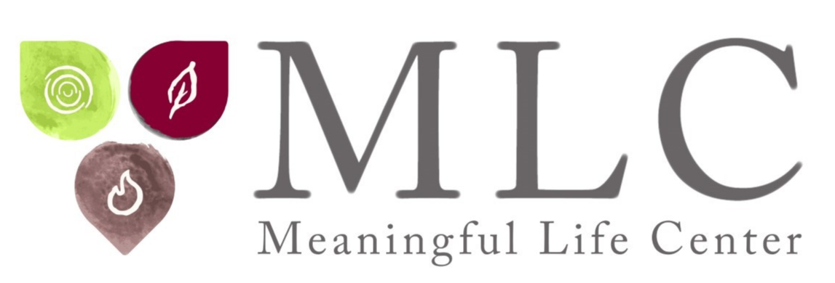

Rabbi Simon Jacobson
Byline BIO:
Rabbi Simon Jacobson shares emotional, psychological, and spiritual skills to help people live their most meaningful lives. An “engaged sage” with an open, empathetic, and non-judgmental approach, he provides clarity, solutions, and new perspectives based on timeless teachings. He is the author of the best-selling book “Toward a Meaningful Life” and Founding Dean of The Meaningful Life Center.
Learn more at www.meaningfullife.com.
Broadcast BIO:
Our guest today is considered one of the greatest scholars and most sought-after speakers in the Jewish world, yet his message is for all people. Rabbi Simon Jacobson is the author of the best-selling book “Toward a Meaningful Life” and Founding Dean of The Meaningful Life Center.
Learn more at www.meaningfullife.com.
Full BIO:
Rabbi Simon Jacobson is author of the best-selling book “Toward a Meaningful Life,” a William Morrow publication that has sold over 400,000 copies to date and has been translated into Hebrew, French, Spanish, Dutch, Portuguese, Italian, Russian, German, Hungarian, Czech, and Georgian.
Rabbi Jacobson heads The Meaningful Life Center, which bridges the secular and the spiritual through a wide variety of live and online programming. The Meaningful Life Center presents to people of all backgrounds the universal teachings of Torah as a blueprint for life.
MLC, called a “Spiritual Starbucks” by the New York Times, is an outgrowth of Rabbi Jacobson’s teachings, which have captured the hearts of thousands of participants over the last 40 years with their spiritual message and profound insights into the human condition.
For over 14 years Rabbi Jacobson, as Editor-in-Chief of Vaad Hanochos Hatmimim, was responsible for publishing the talks of the late Rabbi Menachem M. Schneerson, the Lubavitcher Rebbe, one of the most influential Jewish leaders of the 20th century. Beginning in 1979, Rabbi Jacobson headed a team of scholars that memorized and transcribed entire talks that the Rebbe gave during the Sabbath and holidays, as writing and tape recording are not permitted on holy days. In this position, he was privileged to work in close association with the Rebbe and published more than 1000 of the Rebbe’s talks. He also headed the research team for Sefer Halikutim — an encyclopedic collection of Chassidic thought (26 volumes, published 1977-1982).
Rabbi Jacobson is one of the greatest scholars and most sought-after speakers in the Jewish world today. He has lectured to diverse audiences on six continents and in forty states on psycho-spiritual issues and applying Jewish thought to contemporary life. His voice is rooted in the timeless teachings of Torah, yet at the same time is profoundly timely, relevant, unique, and cutting edge. He has been interviewed on over 300 radio and TV shows, including CBS, CNN, Newsmax, PragerU, PBS, MSNBC, FOX, and NPR. He is also the chairman and publisher of The Algemeiner Journal, the “fastest growing Jewish newspaper in America” according to CNBC, filling the position of his illustrious father, esteemed journalist Gershon Jacobson.
Learn more at www.meaningfullife.com

