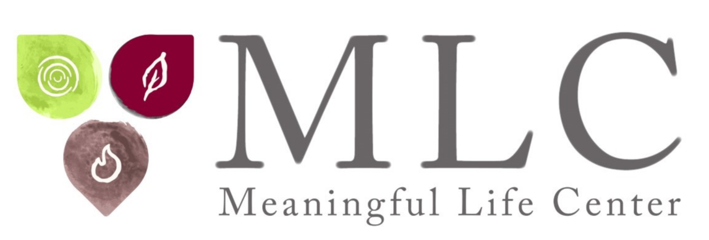

Rabbi Simon Jacobson: Suggested Interview Questions

- You are author of the bestselling book “Toward a Meaningful Life” that has sold more than 400,000 copies worldwide, and dean and founder of The Meaningful Life Center. What does it mean to live a meaningful life?
- You say that fear, anxiety and depression are underlying factors that drive much of human behavior today. What is the secret to overcoming these forces?
- What does Torah and faith wisdom tell us about how to navigate the upheaval we are experiencing in the world today?
- How did the pandemic change the world for good or bad, and what do you believe will be the most lasting changes?
- Why has America grown so politically divided, and what can ordinary people do to help bridge the gap and heal our nation?
- What are some of the key things we can do to create meaningful lives, and how can these actions protect us from stress, strife, worry and depression?
- You say we should strive to be “radical warriors for goodness and kindness.” What does that mean?
- Based on your studies of the Torah and faith wisdom, you outline some keys to building healthy, lasting marriages. How can people keep the spark of intimacy alive, resolve conflicts, and find and maintain fulfilling relationships?
- You say there is a “4000-Year-Old 7-Step Program” to understand our souls and unlock our potential. Please describe how this works.
- How can people “unclutter” their souls to stop doing things that don’t bring them fulfillment and make room for activities that will help them grow and flourish?
- You have worked extensively with people facing addiction, depression, and anxiety. How has the pandemic affected people struggling in these ways, and what are some keys to recovery?
- You are considered among the greatest scholars and most sought-after speakers in the Jewish world today. What does it mean to be a Jew today, and what are key lessons we can learn from the faith to be better people and build a better world?

